**Database Diagram**

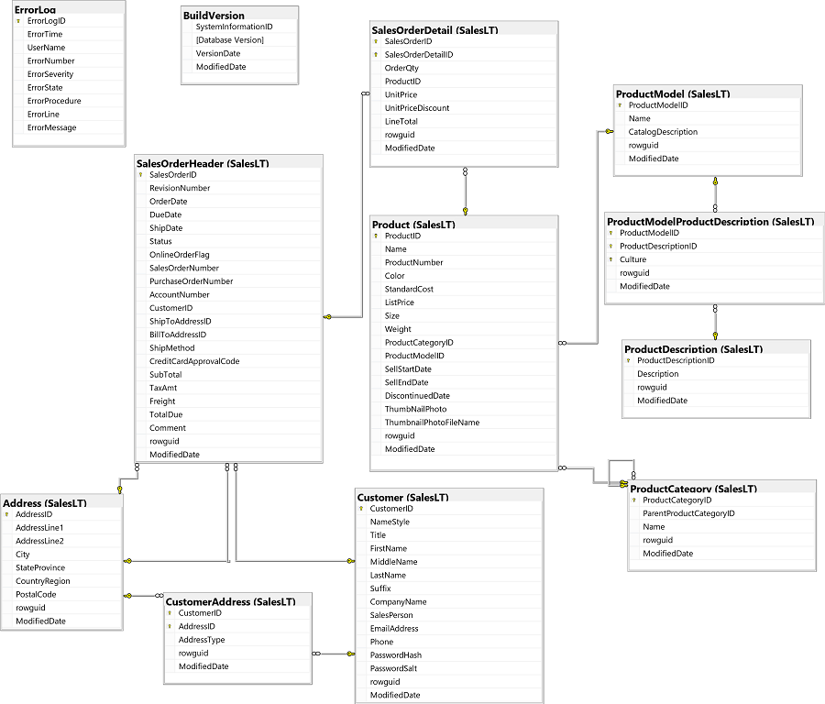

**Task 1: Retrieve data for transportation reports**

The logistics manager at **Adventure Works** has asked you to generate some reports containing details of the company’s customers to help to reduce transportation costs.

**1.1 Retrieve a list of cities**

Initially, you need to produce a list of all of you customers' locations. Write a Transact-SQL query that queries the SalesLT.Address table and retrieves the values for City and StateProvince, removing duplicates , then sorts in ascending order of StateProvince and descending order of City.

SELECT DISTINCT City

              , StateProvince -- Write a Transact-SQL query that queries the SalesLT.Address table and retrieves the values for City and StateProvince, removing duplicates

FROM SalesLT.Address

ORDER BY StateProvince ASC, City DESC  -- then sorts in ascending order of StateProvince and descending order of City.

**1.2 Retrieve the heaviest products information**

Transportation costs are increasing and you need to identify the heaviest products. Retrieve the names, weight of the top ten percent of products by weight.

SELECT TOP 10 PERCENT Weight

                    , Name

FROM SalesLT.Product

ORDER BY Weight DESC -- Retrieve the names, weight of the top ten percent of products by weight.

**Task 2: Retrieve product data**

**The Production Manager at Adventure Works** would like you to create some reports listing details of the products that you sell.

**2.1 Filter products by color and size**

Retrieve the product number and name of the products that have a color of black, red, or white and a size of S or M.

SELECT ProductNumber

    , Name           -- Retrieve the product number and name of the products

FROM SalesLT.Product

WHERE Color IN ('Black','Red','White') AND Size IN ('S','M') -- that have a color of black, red, or white and a size of S or M.

**2.2 Filter products by color, size and product number**

Retrieve the ProductID, ProductNumber and Name of the products that must have Product number begins with 'BK-' followed by any character other than 'T' and ends with a '-' followed by any two numerals.

And satisfy one of the following conditions:

* color of black, red, or white
* size is S or M and

SELECT ProductID

     , ProductNumber -- Retrieve the ProductID, ProductNumber and Name of the products

     , Name

FROM SalesLT.Product

WHERE ProductNumber LIKE 'BK-[A-S,U-Z]%-[0-9][0-9]' -- that must have Product number begins with 'BK-' followed by any character other than 'T' and ends with a '-' followed by any two numerals.

AND (Color IN ('Black','Red','White') OR Size IN ('S','M')) -- And satisfy one of the following conditions: color of black, red, or white + size is S or M

**2.3 Retrieve specific products by product ID**

Retrieve the product ID, product number, name, and list price of products whose product name contains "HL " or "Mountain", product number is at least 8 characters and **never have been ordered**.

SELECT ProductID

     , ProductNumber -- Retrieve the ProductID, ProductNumber and Name and ListPrice of the products

     , Name

     , ListPrice

FROM SalesLT.Product

WHERE (Name LIKE '%HL%' OR Name LIKE '%Mountain%') -- product name contains "HL " or "Mountain"

    AND ProductNumber LIKE '_______%'  -- product number is at least 8 characters

    AND ProductID NOT IN (SELECT ProductID

                          FROM SalesLT.SalesOrderDetail)  -- product have never been ordered